Sri Raghavendra Educational Institutions Society (R)

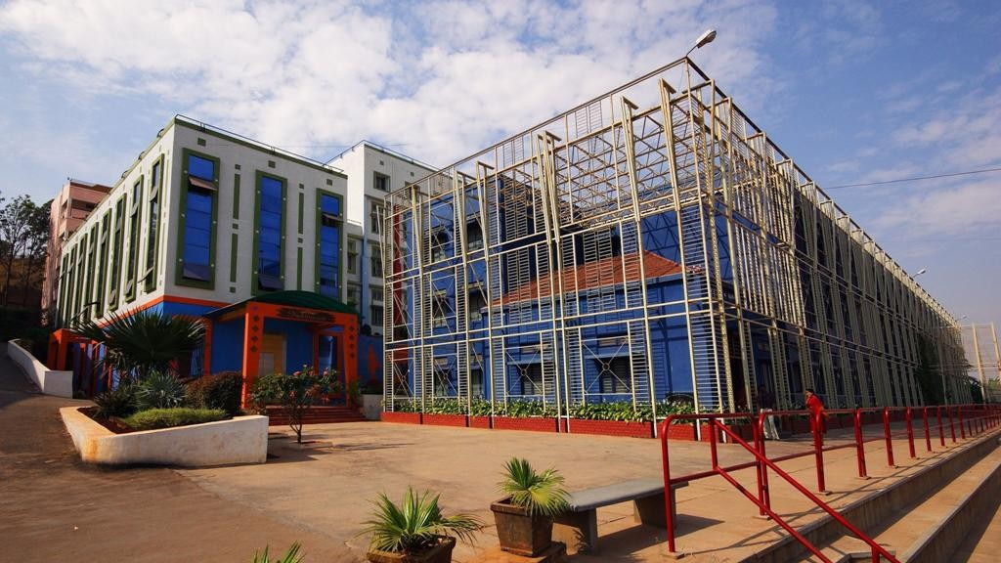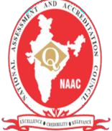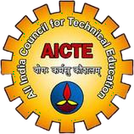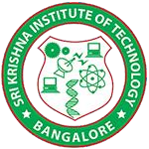

**Sri Krishna Institute of Technology**

(Approved by AICTE, Accredited by NAAC, Affiliated to VTU, Karnataka)

**Course: Physical Education Student: Madan R Department: Civil Engineering**

[**www.skit.org.in**](http://www.skit.org.in/)

PHYSICAL EDUCATION AND SPORTS

Physical Education is an integral part of the total education system. It helps in the attainment of the ultimate aim of education i.e. the achievement of holistic development. Games and Sports play a vital role in the student’s life. A student should study hard to be successful in competitive examinations. But, he should also play games and sports to enjoy the health and vigour of life. Along with bookish learning, a student should spend his time on games and sports also.

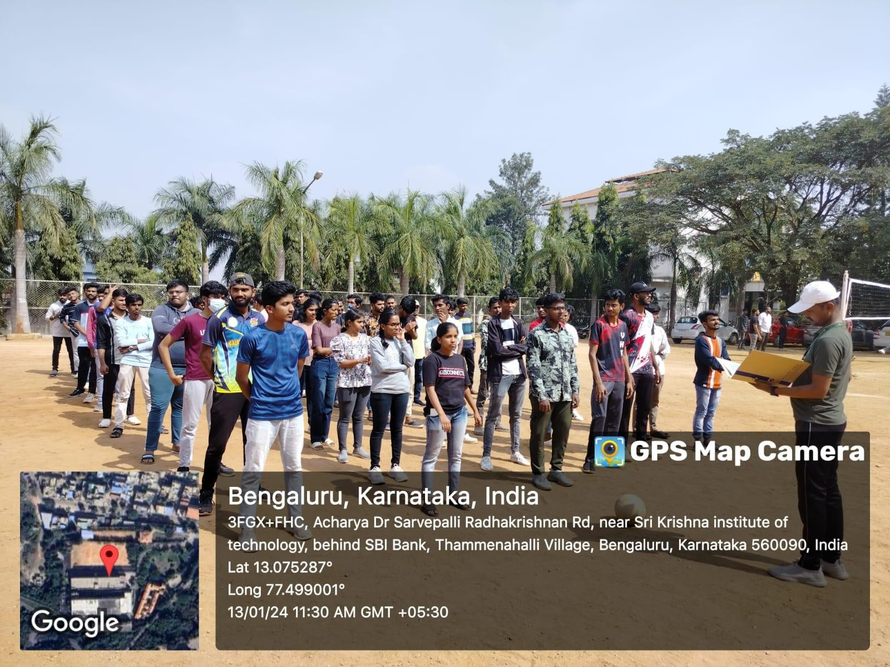

# WARM UP EXERCISES

Static stretching involves holding a position for 30 seconds or more to elongate the muscle while a warm up involves stretching through a range of motion.

Your body needs to warm up by slowly increasing your heart rate and breathing rate. In doing so, you are lubricating your joints, which will give you better range of motion and better elasticity in tendons and ligaments.

* SOME EXERCISES ARE:-

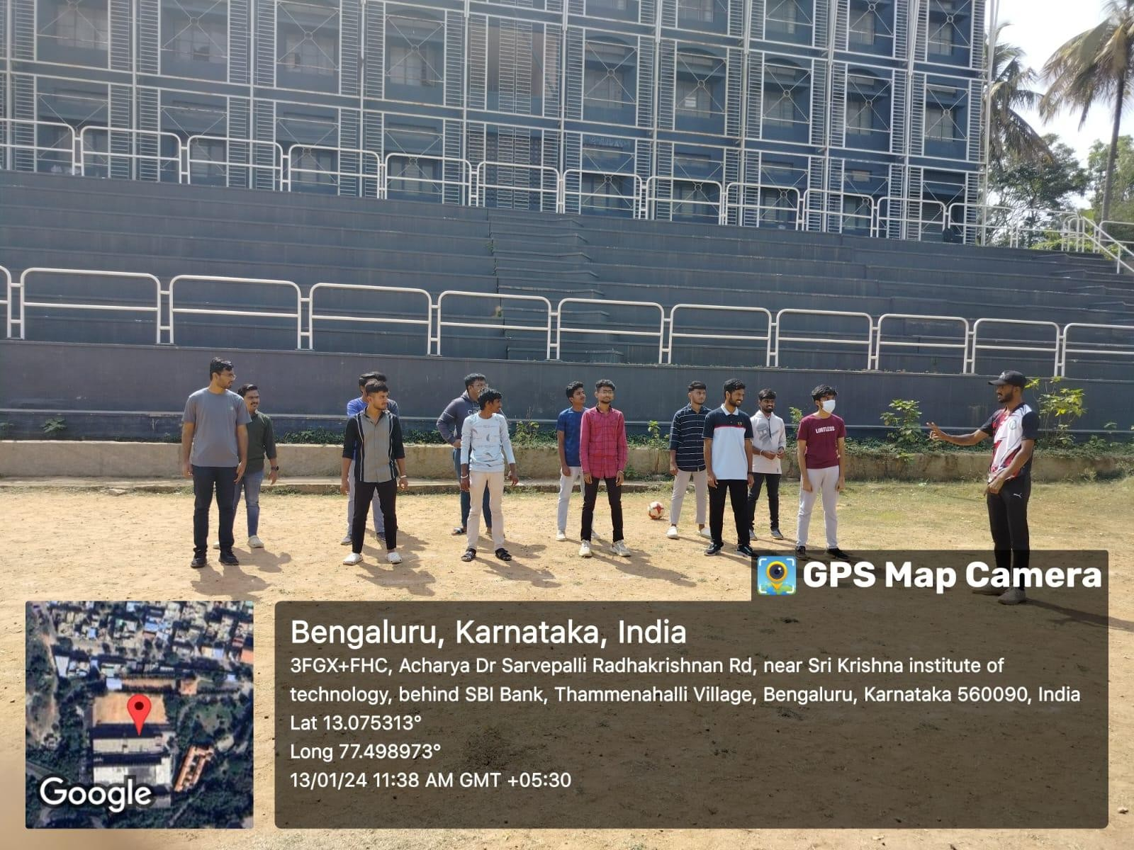

**BACK AND FORTH SPRINTS**

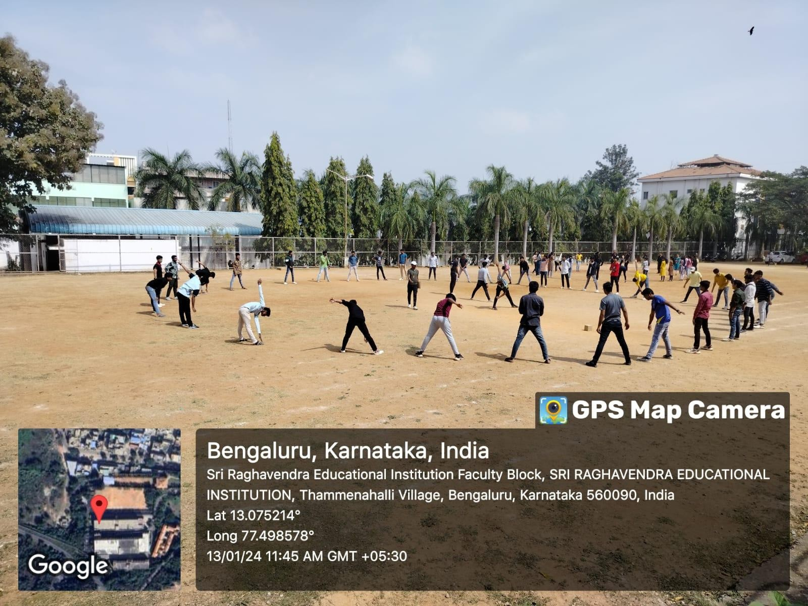

**FULL BODY STRETCHES**

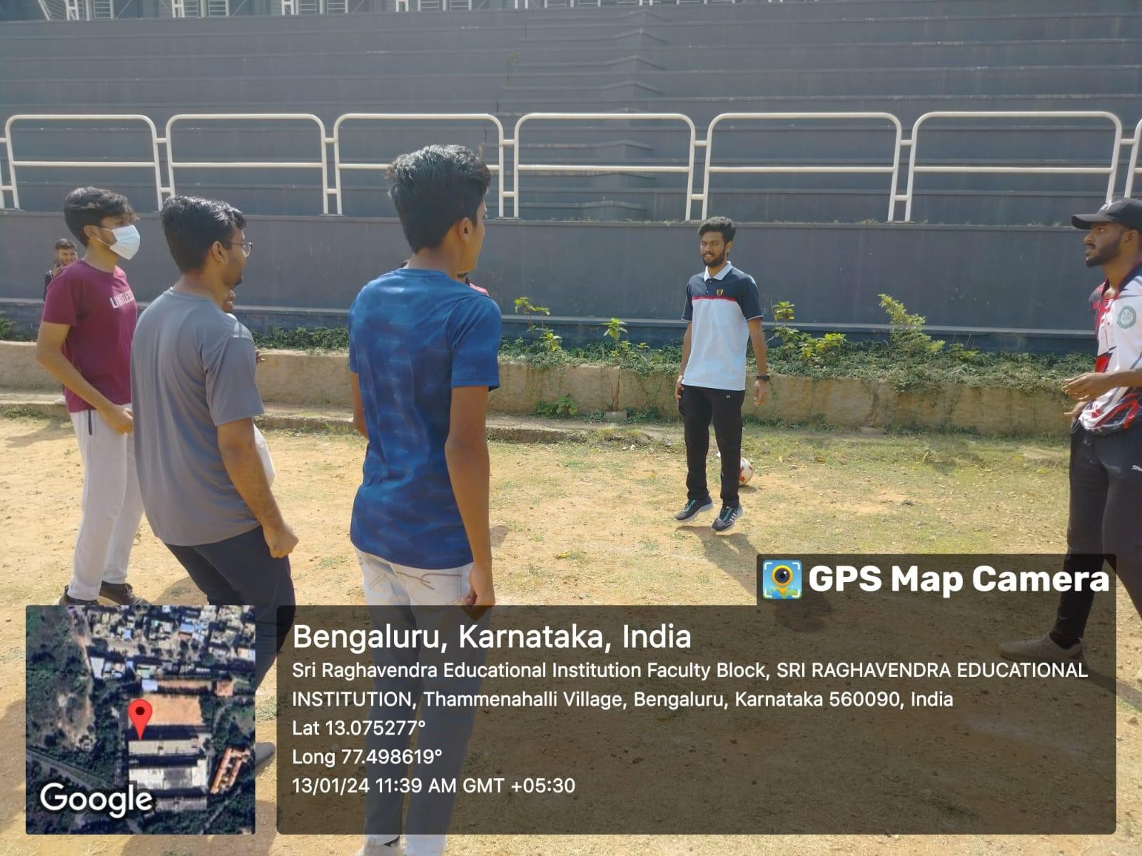

**SKIP JUMPS**

# VOLLEY BALL

**Volleyball**, game played by two teams, usually of six players on a side, in which the players use their hands to pass a ball back and forth(without carrying it) over a high net, trying to make the ball touch the court within the opponents’ playing area before it can be returned. To prevent this a player on the opposing team bats the ball up and toward a teammate before it touches the court surface—that teammate may then volley it back across the net or bat it to a third teammate who volleys it across the net. A team is allowed only three touches of the ball before it must be returned over the net.

# FOOTBALL

**Football** or **Soccer**, is a team sport played between two teams of 11 players each, who primarily use their feet to propel a ball around a rectangular field called

a pitch. The objective of the game is to score more goals than the opposing team by moving the ball beyond the goal line into a rectangular-

framed goal defended by the opposing team. Traditionally, the game has been played over two 45- minute halves, for a total match time of 90 minutes. With an estimated 250 million players active in over 200 countries and territories, it is the world's most popular sport.